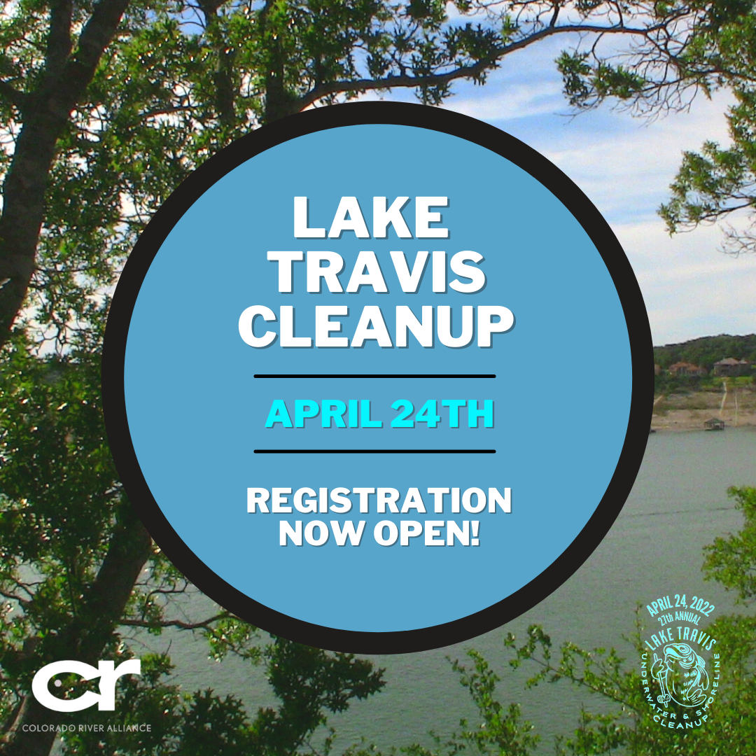
Tues. 3/8 Registration Opens
Lake Travis Cleanup registration is now open! We have opportunities such as diving cleanups, shoreline cleanups, waterway cleanups, and much more! Lake Travis Cleanup is the largest scuba diving, shoreline and waterway litter pickup in Texas. Register today to reserve your spot at https://laketraviscleanup.org/. We're also offering a virtual option for those who want to help from the comfort of their own home.
For 27 years, the community has come together to help protect and preserve Central Texas’ most vital resource. Join us in doing your part to keep them clean! We look forward to seeing everyone clean up our beautiful parks and waterways on April 24th.

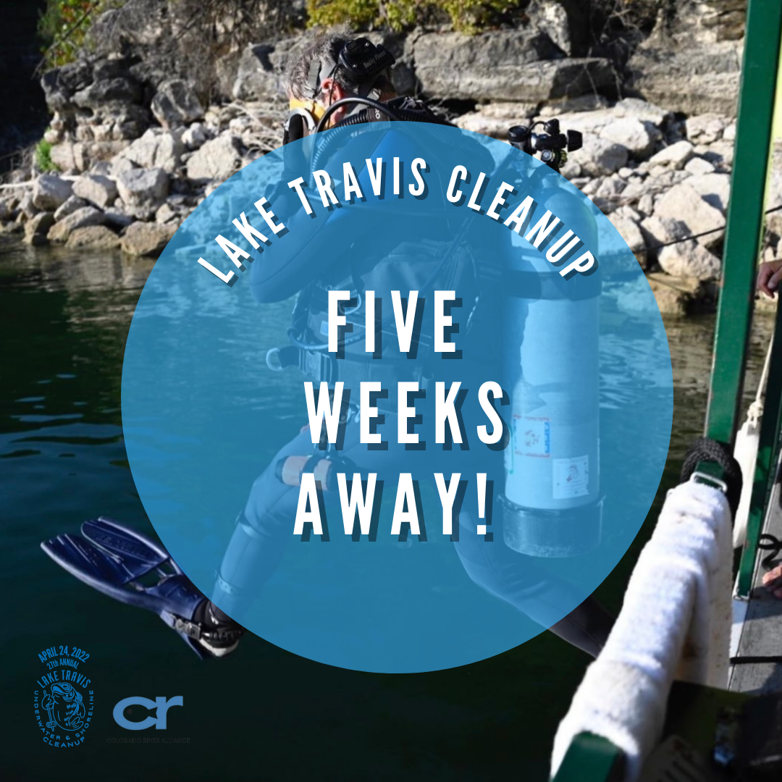
Mon. 3/21 5 Weeks away
We are only a little over a month away from the Lake Travis Cleanup, which is happening on Sunday, April 24th. More than 1,000 volunteers are expected to remove around five tons of trash and debris from the waters and shoreline of Lake Travis and at parks across Travis County. This annual effort is the largest ongoing community event designed specifically to keep the Lake, our drinking water, and our community healthy and clean. We want to beautify our parks, and we want your help!
We need site leaders and regular volunteers! If you would like to volunteer please contact volunteer@coloradoriver.org! Not only will you be beautifying your city, you will receive a swag bag for your time! Register at https://laketraviscleanup.org/.

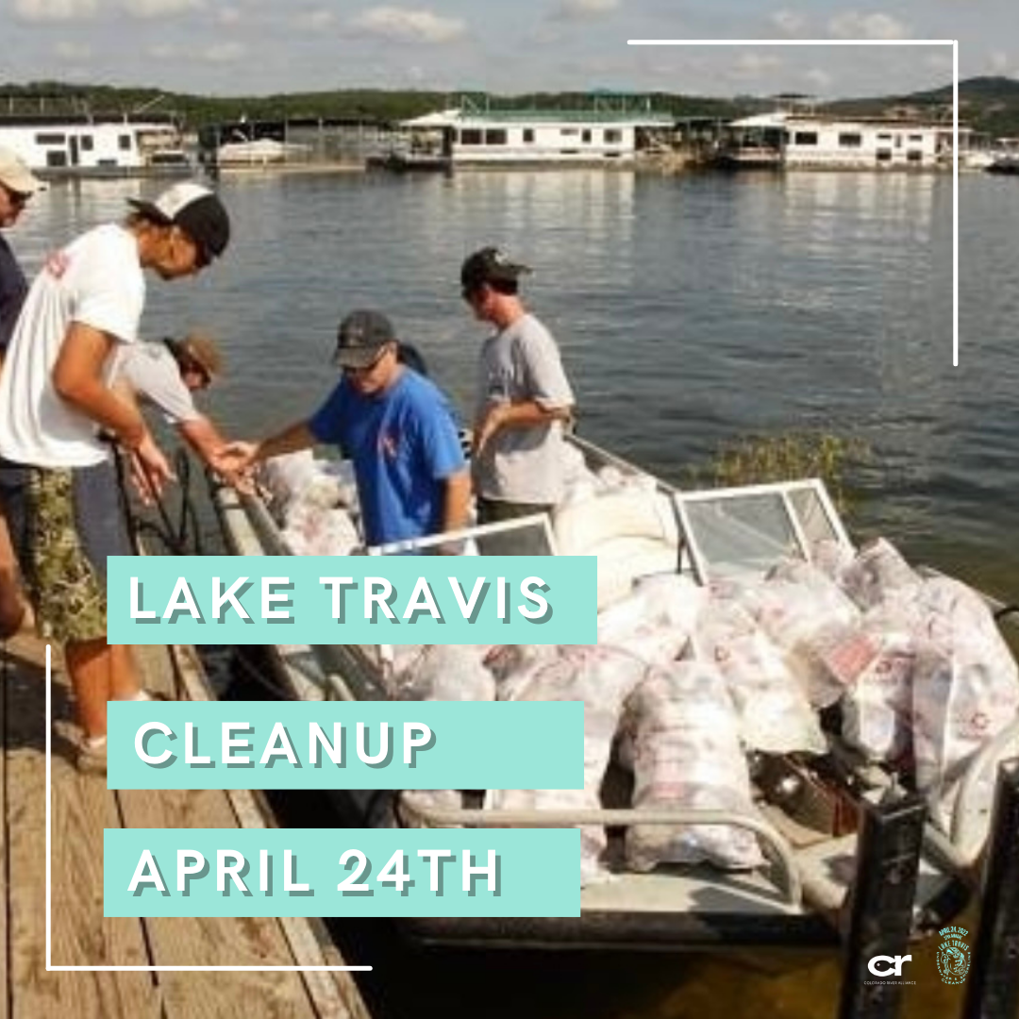
Mon. 3/28
Environmentally conscious but unsure how to help? Did you know that since the first Lake Travis Cleanup in 1994 over 108 TONS of trash have been cleaned up? You can help clean up even more by joining us on April 24th. Reserve your spot and help keep our wonderful parks and waterways clean! We're also offering a virtual option for those who want to help from the comfort of their own home. Visit https://laketraviscleanup.org/ to register today.

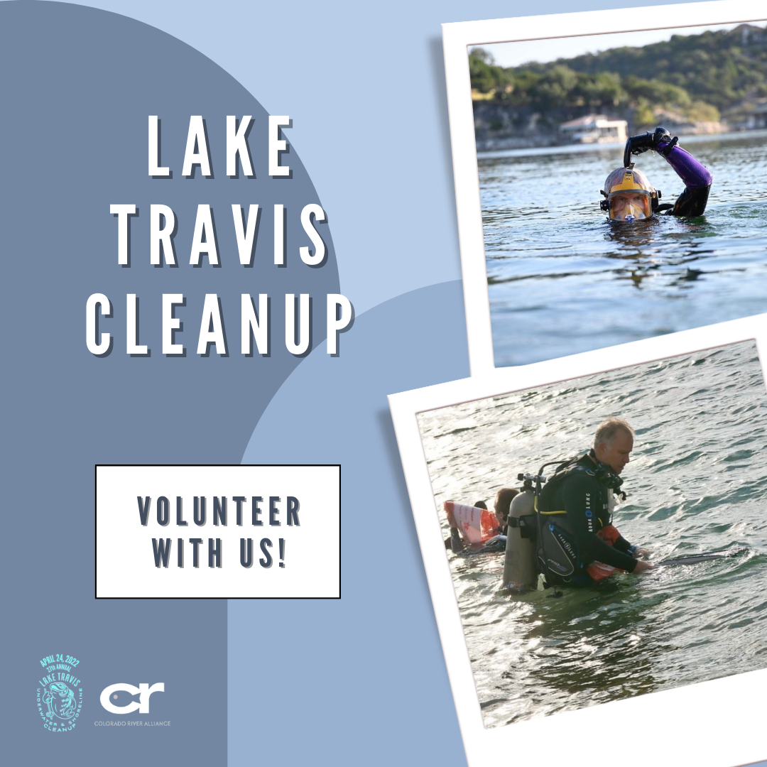
Mon. 4/4 Reminder
Registration for the Lake Travis Cleanup on April 24th is still open at https://laketraviscleanup.org/. Reserve your spot today to give back to your community by keeping our parks and waterways clean. The Lake Travis Cleanup is the largest scuba diving, shoreline, and waterway litter pickup in Texas. Together, hundreds of certified scuba divers, along with volunteers of all ages, help collect litter from the bottom of Lake Travis and across the Travis County Parks system. Thank you to all of our volunteers and sponsors who have committed to participate so far.

If you would like to volunteer please contact volunteer@coloradoriver.org! Every volunteer receives a swag bag! We are grateful that we have this community to keep our parks and waterways beautiful!

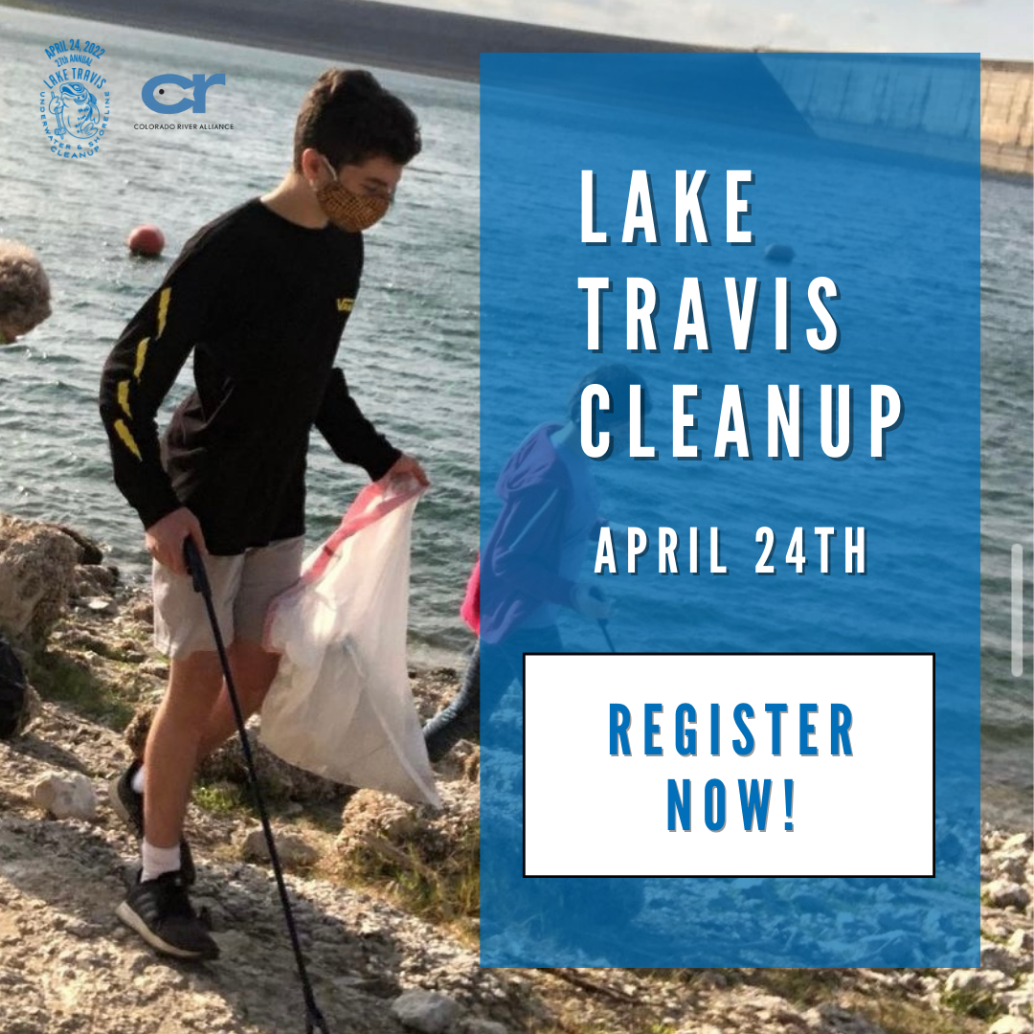
Mon. 4/11
The Lake Travis Cleanup began in 1994 as an informal gathering of local dive shops. Since inception, the event, now managed by a collaboration between the Colorado River Alliance and Travis County Parks, has grown to include underwater efforts as well as trash pickup along the shoreline, near roadways, and throughout parks across the river basin. Register for our Lake Travis Cleanup coming up on April 24th at https://laketraviscleanup.org/. We can’t wait to clean up with you!

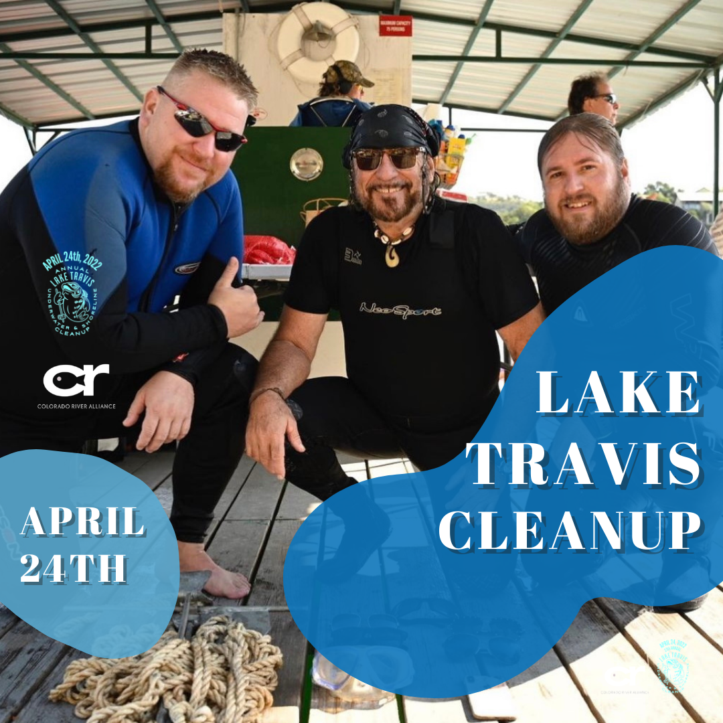
Thurs. 4/13
Every summer, almost 500,000 people visit the Highland Lakes. That is a whole lot of people… and a whole lot of trash. Join the divers, families, County leaders, and staff of the Colorado River Alliance that rally together to raise public awareness of the importance of Lake Travis and the Highland Lakes. Register for the Lake Travis Cleanup on April 24th at https://laketraviscleanup.org/. We're also offering a virtual option for those who want to help from the comfort of their own home. We hope to see you there!

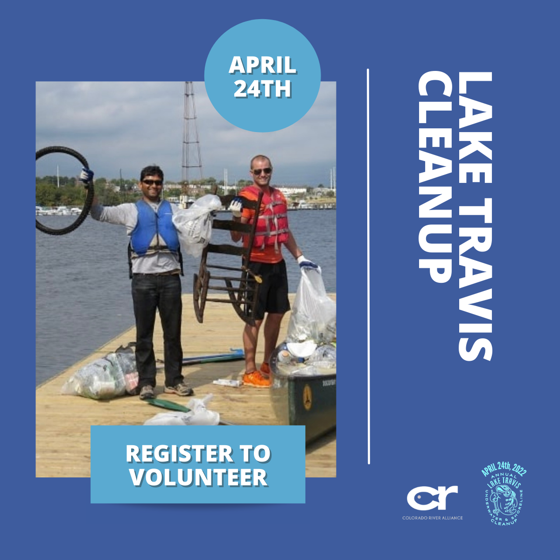
Sat. 4/17 One Week Out
We are officially ONE WEEK AWAY from our annual Lake Travis Cleanup on April 24th!! There will be shoreline, waterway, park and dive cleanups. Lake Travis Cleanup is the largest scuba diving and shoreline litter pickup in Texas. We would love to see you there, so be sure to register while there is still time at https://laketraviscleanup.org/.
Also, a BIG thank you to all of our wonderful volunteers and sponsors who have signed up so far! You are the most vital part in keeping our water clean. It’s not too late to sign up! If you would like to volunteer please contact volunteer@coloradoriver.org! We're also offering a virtual option for those who want to help from the comfort of their own home. Not only will you be helping your community, you’ll get a swag bag as well. If you are participating, be sure to tag us in any photos you have, or send them to us!
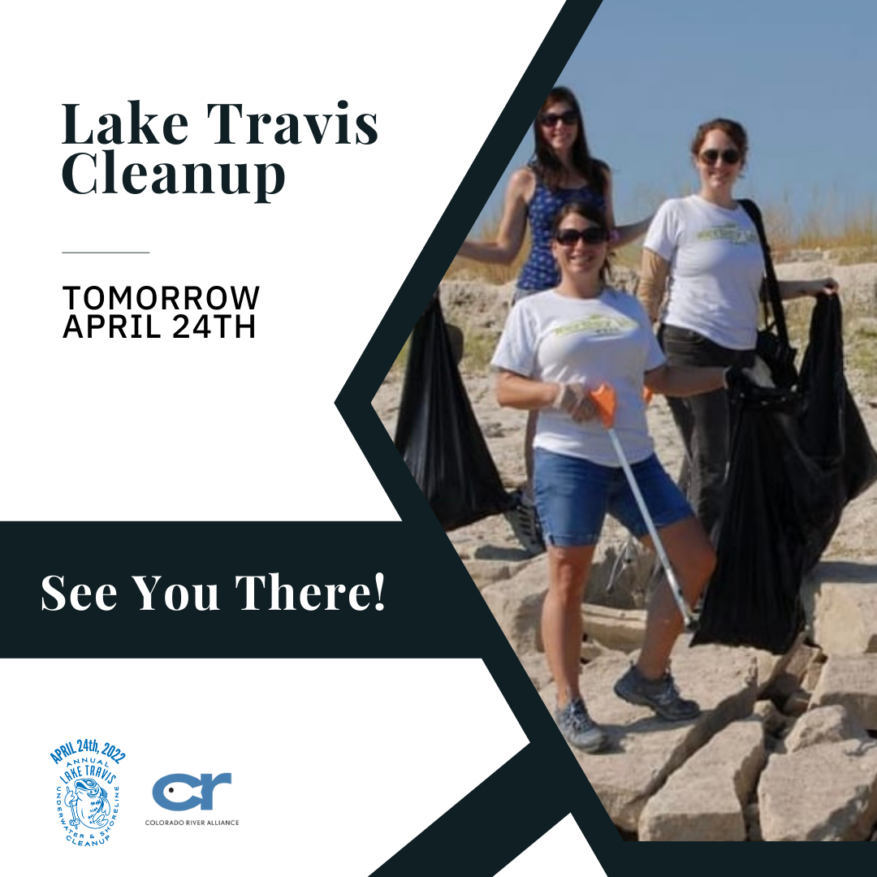
Fri. 4/23 DAY BEFORE (Unusual Things)
The annual Lake Travis Cleanup is TOMORROW! We are so excited to see all of our wonderful volunteers cleaning up and making our parks and waterways a better place. If you are participating tomorrow, be sure to tag us in any photos you take! Get those cameras out because we’re having a "Dirtiest Volunteer Award, "Largest Item Found Award,” and “Most Unusual Object Award.”

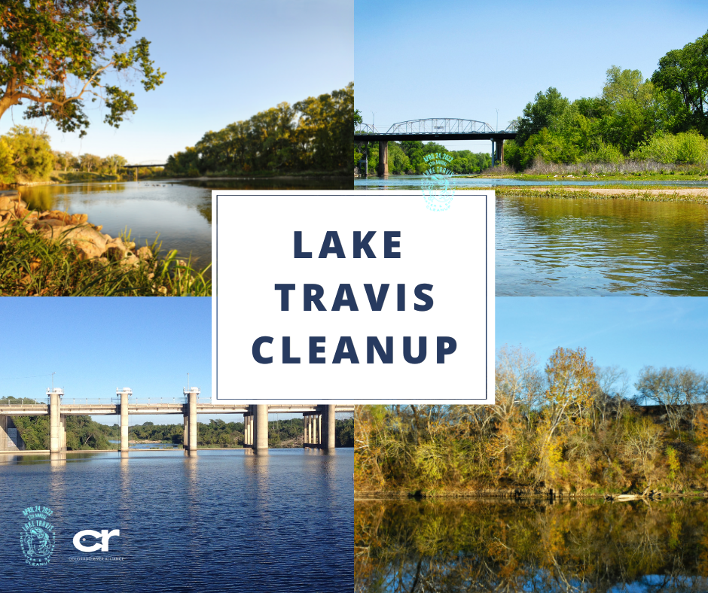
Sun. 4/24 DAY OF:
It’s finally here! Today is the day that we clean up our parks and waterways for the 27th annual Lake Travis Cleanup! Thank you to everyone who has volunteered their time today and every today to keep our city healthy and beautiful.
*Share posts in stories*
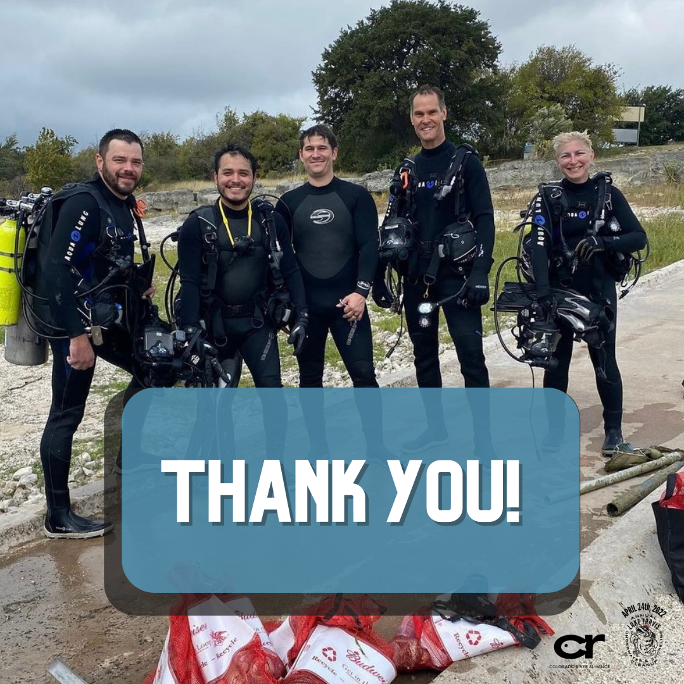
Mon. 4/25 DAY AFTER: Thank you
Thank you to everyone who participated in our annual Lake Travis Cleanup! We loved seeing everyone giving back to their community, and cleaning up our wonderful parks and waterways. We officially collected ____ pounds of trash! WOW! We couldn’t have done it without all of our wonderful volunteers! Thank you for your dedication to keeping this city beautiful.

Photos:
"Dirtiest Volunteer Award, "Largest Item Found Award,” and “Most Unusual Object Award.”

Hashtags:
#laketravis #laketraviscleanup #cleanwater #cra #coloradoriveralliance #coloradoriver #texascoloradoriver #texasrivers #texaswater #texasparks #texaslakes #lakes #rivers #laketraviscommunitycleanup #austintexas #atx #atxlifestyle #austinlifestyle #traviscounty #h2o #texaswaterways #cleanup #volunteers #divers #shoreline #trash #trashpickup

